OLF DEPLOYMENT

Installation path in Client Server:
172.44.406.10 (application server)
Services- D:\QA4.0\ services
UI- D:\QA4.0\Ui
PDF- D:\QA4.0\olfdn-hyqa-pdf
DB- D:\ QA4.0\db
172.44.106.246 (camera server)
Video- D:\QA4.0\camera

BACKUP:
- Create a folder with today’s date in E-Drive.
- Copy the existing folders: services, ui, olfdn-hyqa-pdf from the above paths D:\QA4.0 to the newly created folder in E-Drive.
- Services: Replace the existing jar files in D:\QA4.0\services with the new jar files for all the services.
- UI: Replace the existing build folder in D:\QA4.0\Ui with the new build folder.
- If any changes in the olfdn-hyqa-pdf replace the existing folder in D:\QA4.0\ with the new folder.
- For camera backup copy files inside D:\camera except for D:\camera\videos due to very large space and paste it in E\camera backup
DB BACKUP & RESTORE:
- Open pgAdmin, and open the local server: PostgreSQL 15 with password: postgres
- Right Click on the existing DB: army_olf_dn, select backup and specify the path (D:\QA4.0\db) for the backup file and save it as .sql extension.
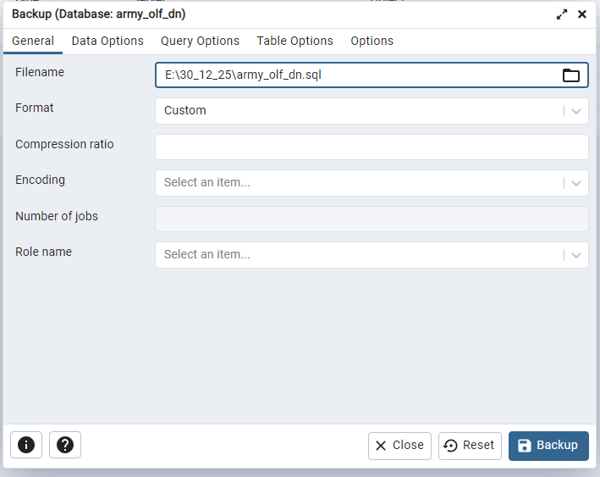
- Once the backup is successful, then right click on the existing DB: army_olf_dn and then select Delete(Force)/Drop(Force) to delete the DB.
- Right Click on Database and Create Database with the name army_olf_dn.
- Right click on the newly created DB, then select restore. Browse the new DB dump file and select the Role name as olms_user and restore.

STEPS FOR DEPLOYMENT
- Open index.html file which is present in “D:\QA4.0\Ui\build” and update the host-api, host-pdf-api, cv2_ip with the Client Server IP address i.e. 172.44.106.10 for host-api, host-pdf-api and 172.44.106.246 for cv2_ip respectively .
- Ports for host-api is 8766, host-pdf-api is 5001 and for cv2_ip is 5001
- Go to the path “D:\QA4.0\ services” and run the “start_microservices.bat” file.
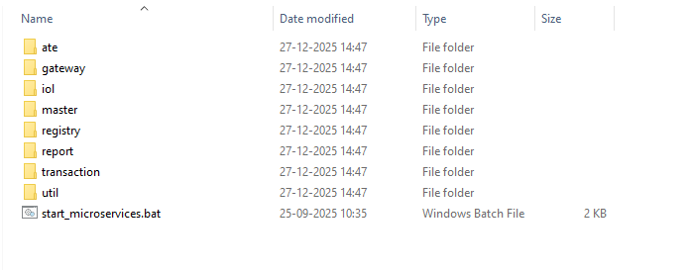
- Make sure that all the services have been started successfully.
- Go to the path “D:\QA4.0\Ui” and run the “start_ui.bat” file.
- Open Command Prompt from the path “D:\QA4.0\olfdn-hyqa-pdf” and execute run command: npm start
- Go to the path “D:\camera” inside camera server and run the “main.exe” file.
- Go to browser and check with the URL: http://172.44.106.10

